**REDSHIFT**

Amazon redshift is a cloud data warehouse wherein data is collected from various sources and is kept at one place which is the warehouse and that can be used for the analysis purpose.

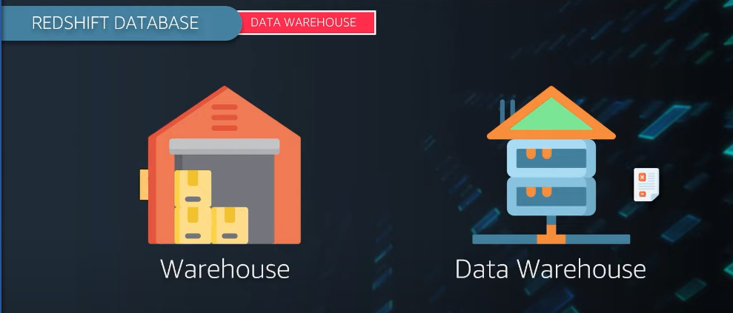

Now let us understand a scenario in which we have data from various sources such as stream data,relational data,multimedia,

Then all the collected data is cleaned so means we transform it.

After that the cleaned data is loaded into the target systems.

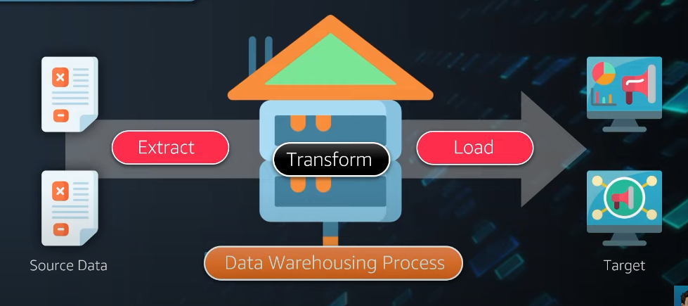

**Source of data**  can be transactional,erp and bulk data which the companies have.Now suppose you have a huge data of financial data.

The raw data which comes from multiple sources needs to be cleaned and structured.So this id done with an etl process and the segregated data is stored in various data marts.

Hence we can say that a data warehouse is a collection of data marts.

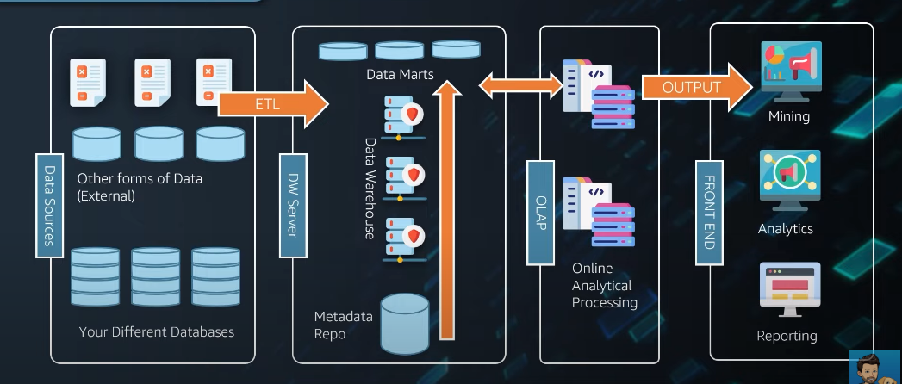

After storing the data in various data marts this data is used for olap which is the online analytical processing as companies may have different pricing based on the geography,people,requirement so they carry out the analysis on their own ways.

Olap organizes data in multi dimensional data which can be used by team sfor analytivs,mining,reporting.

**ADVANTAGE OF HAVING A CLOUD DATA WAREHOUSE**

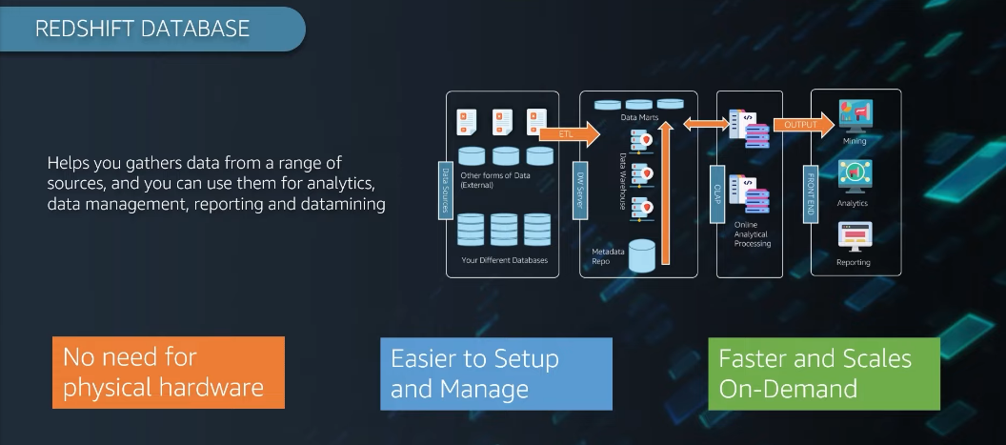

ARCHITECTURE OF  **REDSHIFT DATAWAREHOUSE**

Amazon redishift is an enterprise level petabyte scale fully managed data warehousing service.It is an enterprise-class relational database query and management system.

The clients running etl,mining and easily have access to our redshift using an odbc and jdbc.

In warehouse we have a concept of clusters.

In clusters there is a leader node which looks at all the queries that come to our warehouse an dthey know how to resolve the complex queries.

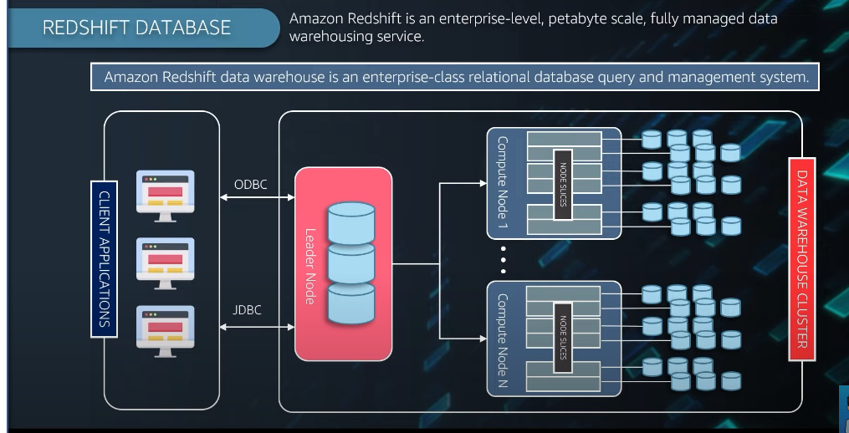

Leader node acts as the master nodes so it handles all the critical queries and preparws an execution plan on how those queries have to be solved an dthen assignes to the computer nodes.

**Compute nodes**

The compute nodes have its own cpu,memory and disks.

You can scale that when you need to.node slices in the computenodes work in parallel to have a better performance and fast execution.

**NOTE**

Redshift works on postgres an deach cluster has its own dd an dworks on rdbms.

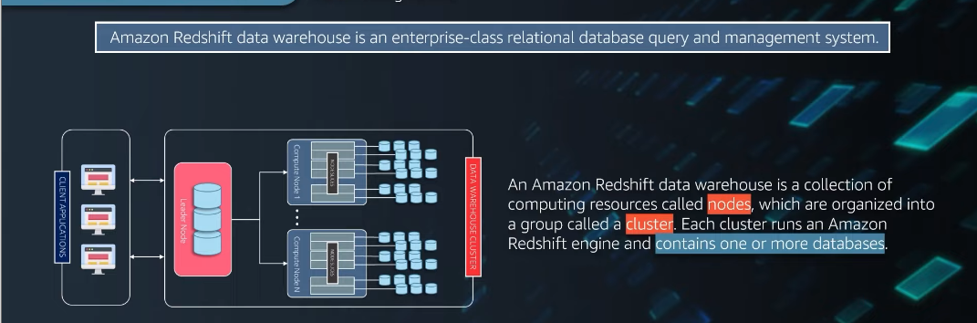

Leader nodes makes an execution plan on how the queries need to be solved.Then it compiles the code and allocates to the compute nodes for further use.

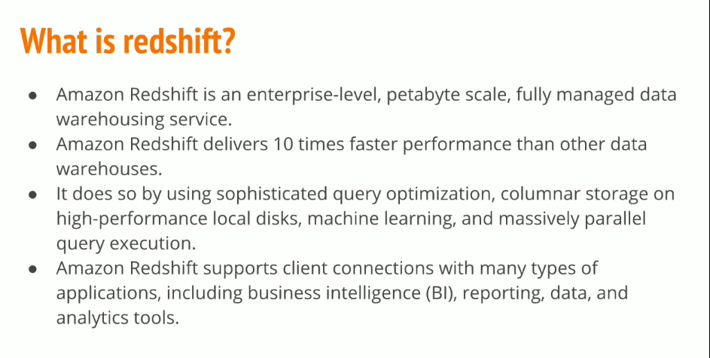

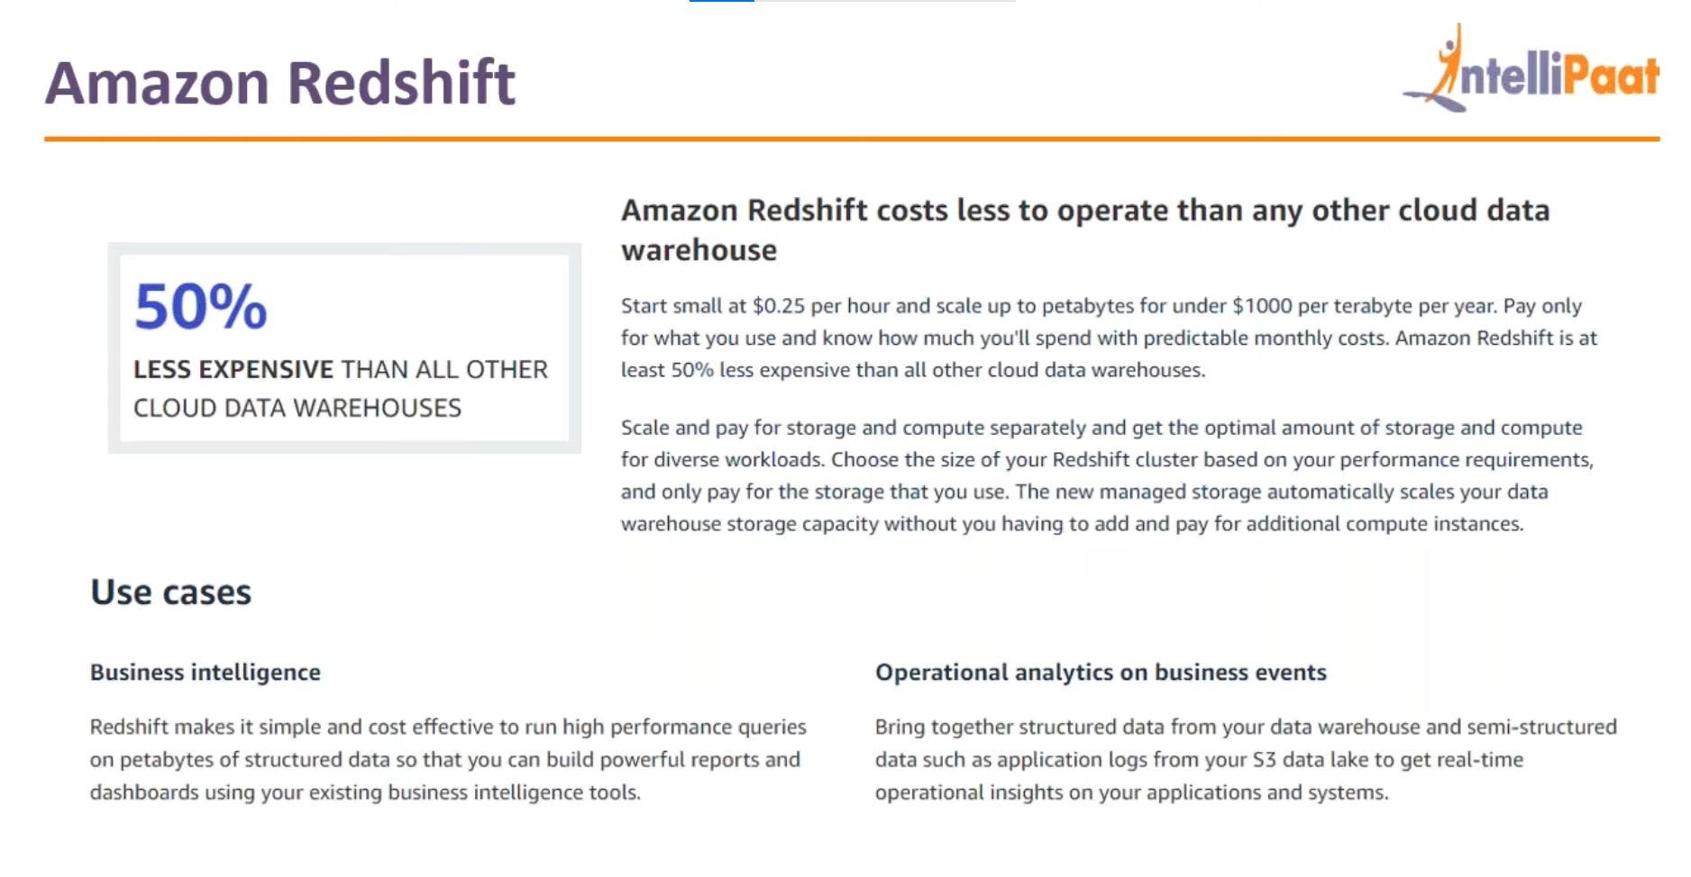

**AMAZON REDSHIFT ARCHITECTUR**

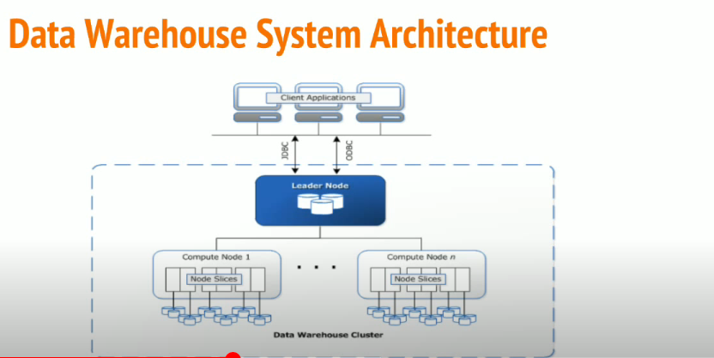

In a redshift architecture there are the client who may be bi or etl and they directly interact with the leader node using the postgres and standard odbc and jdbc connections.

The leader node will handle all the compalex queries and will forward thme to the computer nodes.

Based on the execution pan the elader node comiled code and then distributes the compiled code to the compute nodes and assignes a portion of data to each compute node.

**Compute nodes:**

The compute nodes execute the compiled code and send back the result to the elader nodes for aggregation.

Every computer node is partitioned into slices.

Leader nodes distributes the data to the respective slices.

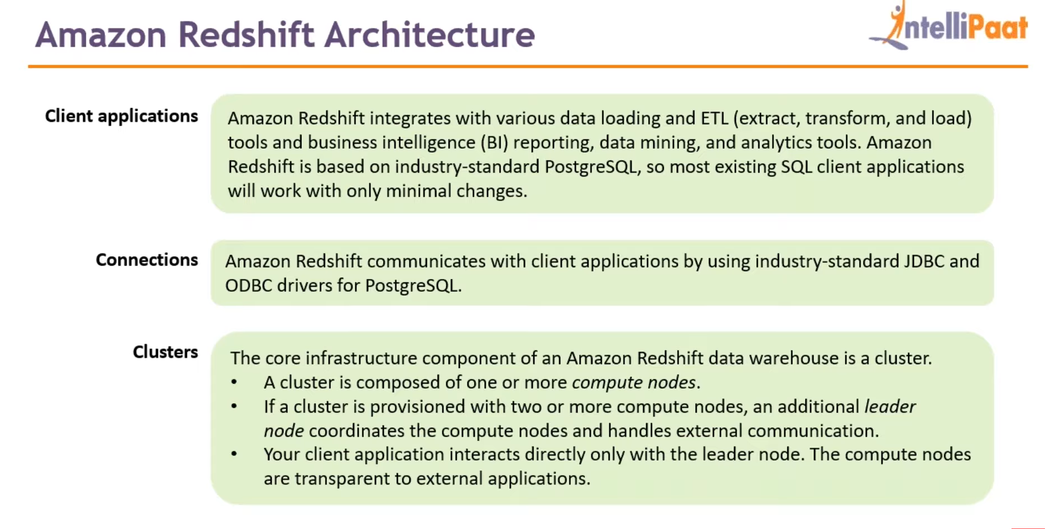

**HANDS ON**

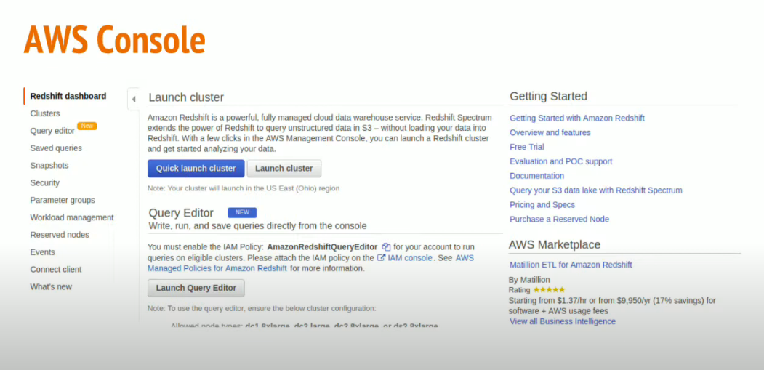

GO TO AWS redshift and create a cluster.

Cluster is 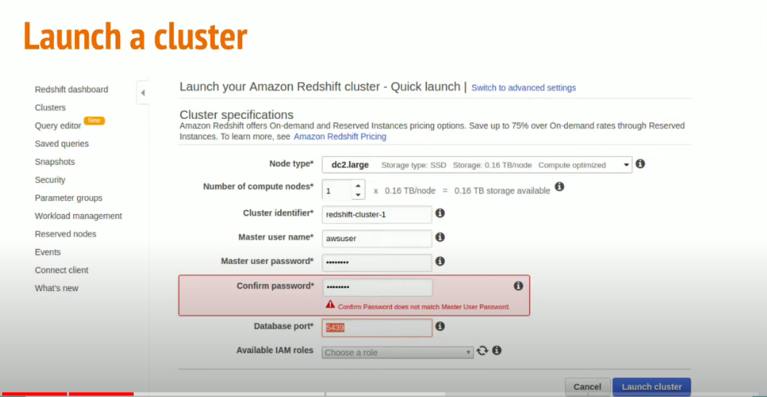

Cluster is created by redshift as can be seen below:

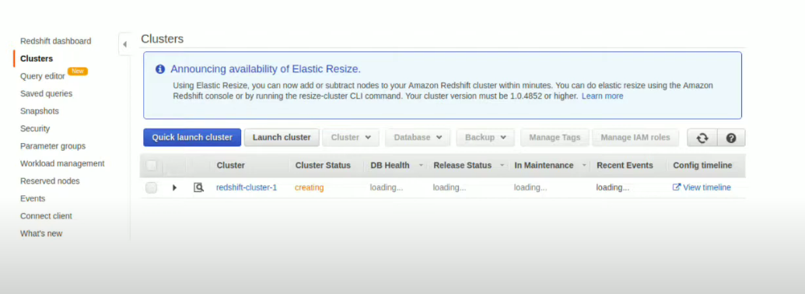

Now we open our launched cluster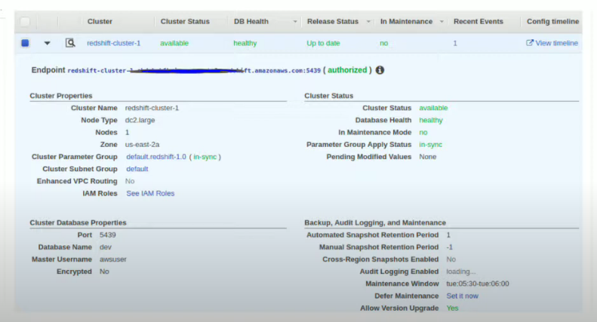

Now we need to configure a vpc so that we can have access to our redshift cluster from our ide.

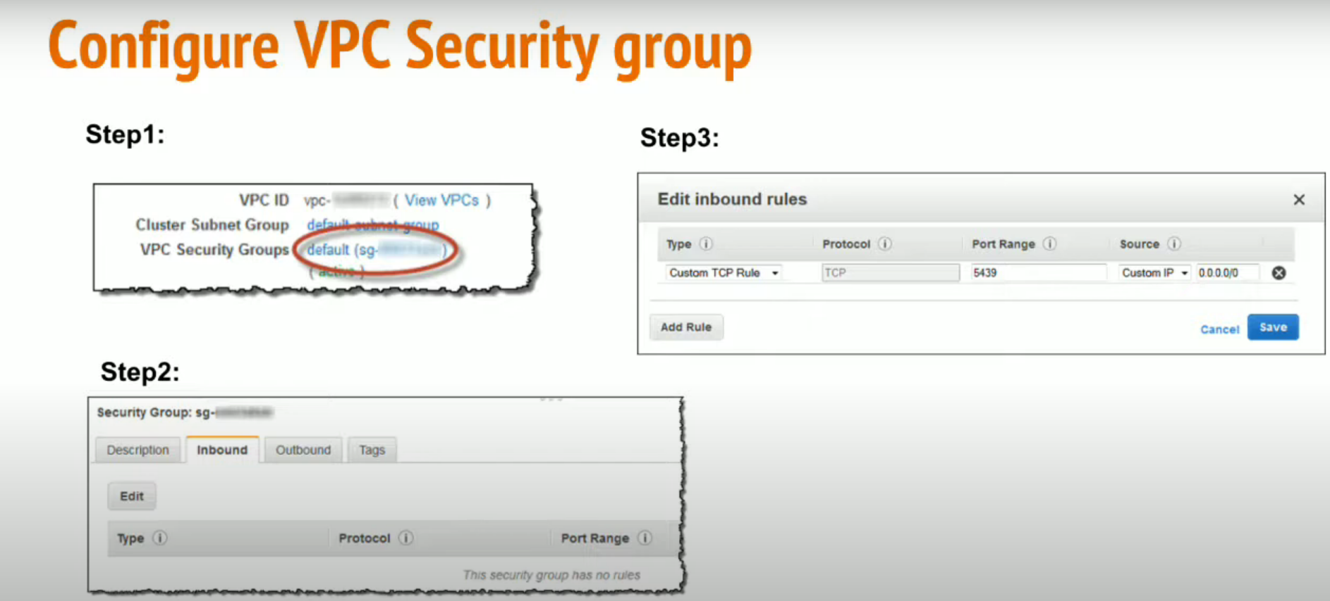

Now save the jdbc url in your notepad

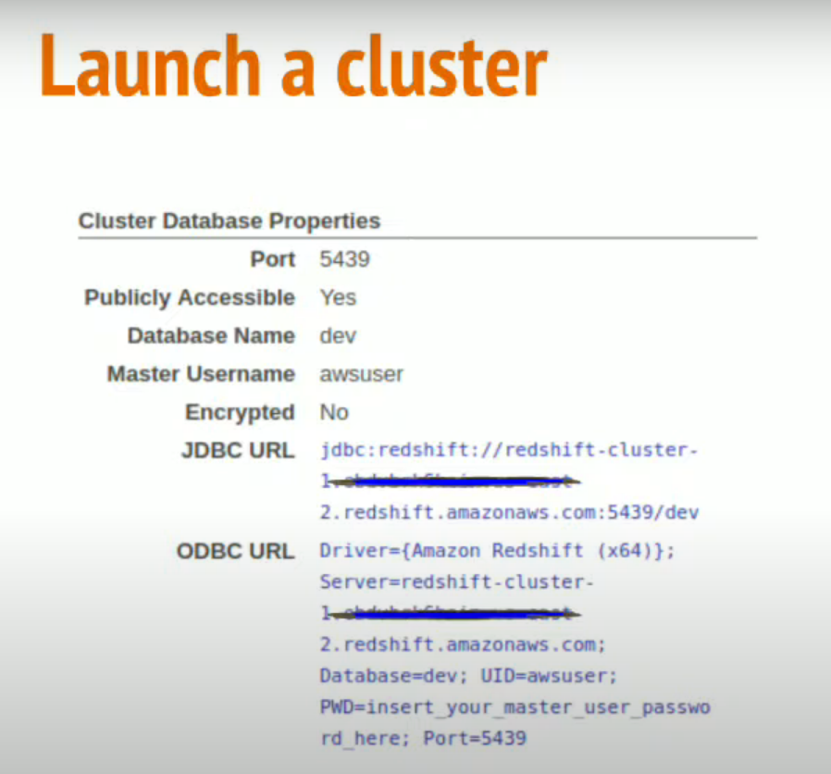

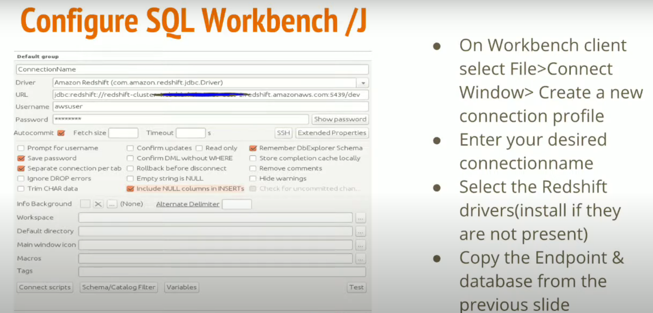

COLUMNAR STORAGE

Columanar storage will drastically improve the oltp transactions as it will reduce the over all io of the disk.

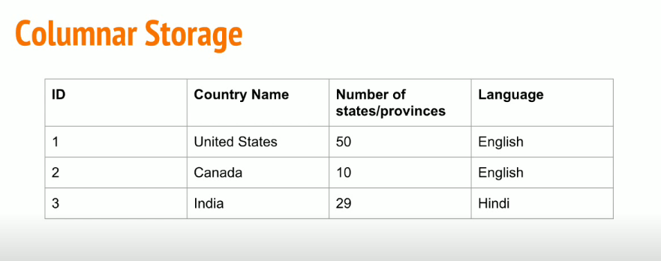

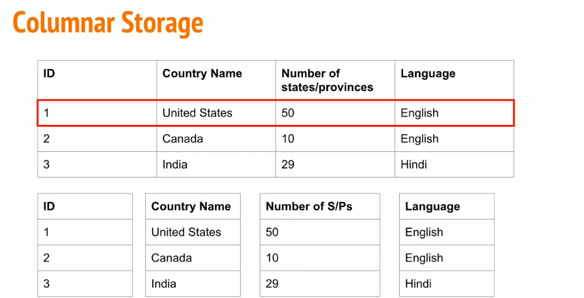

Each data column data stored in ab;oack

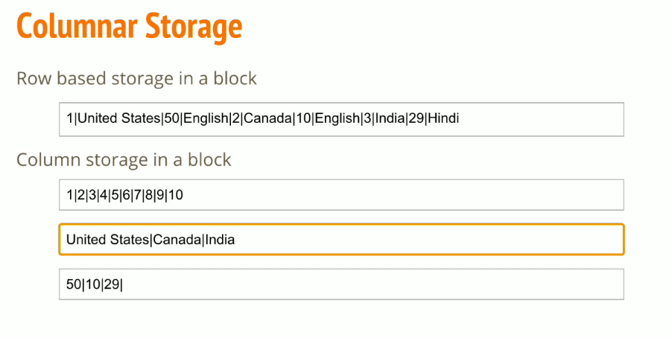

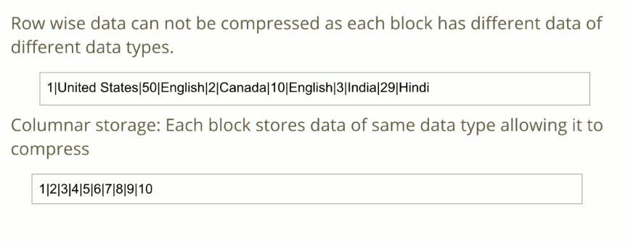

**CRETAE A DB IN REDSHIFT**

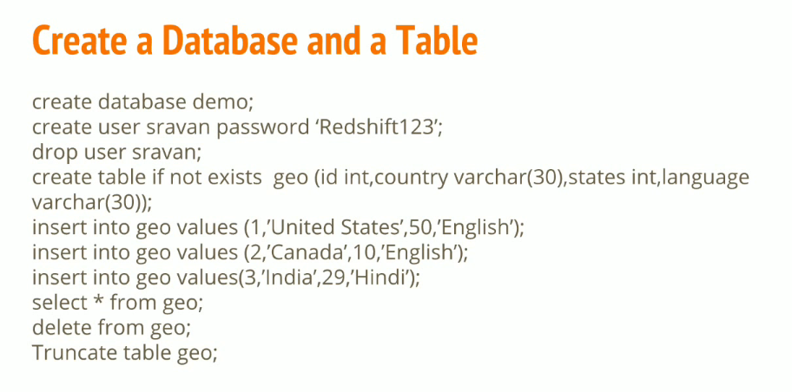

You can create a csv file and upload it in a s3.

Now we want redshift to access our s3 so wewill create an iam role for that

